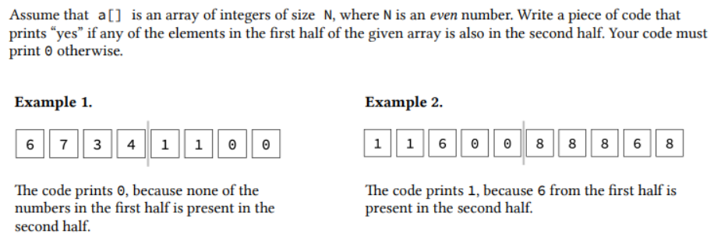

#include <stdio.h>

int slice(int arr[],int size){

int c=0;

for (int i=0;i<(size/2);i++){

for (int j=(size/2);j<size;j++){

if(arr[i]==arr[j]) {

c= 1;

break;

}

else

continue;

}

}

return c;

}

int main()

{ int size ;

printf("Enter array size ");

scanf("%d",&size);

int a[size];

for(int i=0;i<size;i++){

printf("a[%d]= ",i);

scanf("%d",&a[i]);

printf("\n");

printf("%d",slice( a, size));

}

return 0;

}